Kenneth D. Smitley
May 19, 1952 – April 4, 2012

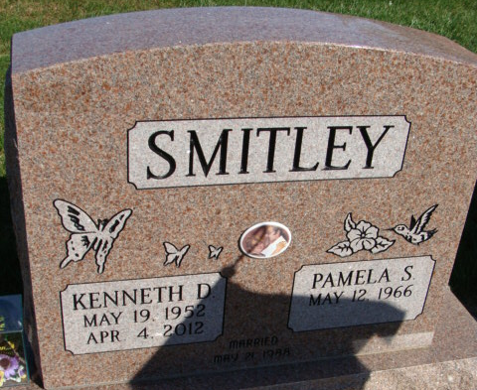
Photo by Alicia Kneuss

Kenneth D. “Toad” Smitley, 59 of Decatur, Indiana died at Lutheran Hospital Wednesday, April 4, 2012. Kenny was born on May 19, 1952 in Decatur, Indiana to the late Calvin E. and Norma J. (Vorhees) Smitley. He married Pamela S. Dyer on May 21, 1988; she survives.
Kenny retired as an assembler for Dana Corp/Spicer AXL. His grandchildren were his everything!
Other survivors include two sons Duane (Melissa) Smitley and Dustin Geels both of Decatur; two daughters Kendra (Jim) Schlemmer and Elizabeth (Mike) Stanton both of Decatur; two sisters Nancy McLeland and Carla (Mike) Rapp both of Decatur; 11 grandchildren and 4 great grandchildren. He is preceded in death by a sister Gayla.
Calling hours are from 4-8 p.m. Friday, April 6, 2012 at Haggard-Sefton & Hirschy Funeral Home. Funeral services will be on Saturday, April 7th at 11:30 a.m. also at the funeral home. Pastor Dan York will be officiating and burial will be in Decatur Cemetery.
Memorials are to the Grandchildren’s Education Fund.

Haggard & Sefton Funeral Home, Adams County, Indiana
April 5, 2012

**
Indiana, U.S., Death Certificates, 1899-2017
Name Kenneth D Smitley
Gender Male
Race White
Age 59
Birth Date 19 May 1952
Birth Place Decatur, Indiana
Death Date 4 Apr 2012
Death Place Fort Wayne, Allen, Indiana, USA
Death Registration Date 2012
Father Calvin E Smitley
Mother Norma J Vorhees
Spouse Pamela S Dyer
Informant Pamela Smitley; spouse; Decatur, Indiana
Burial Decatur Cemetery; Decatur, Indiana
Certificate Number 015346

