John Edward Smitley
June 14, 1943 – June 4, 1994

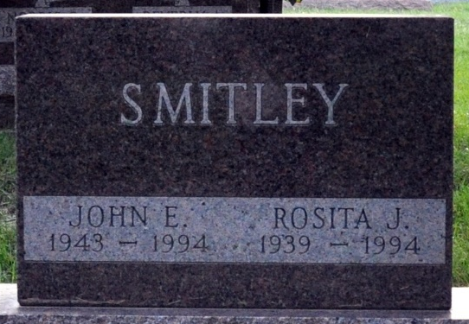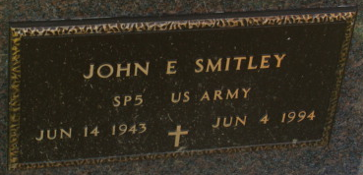
Photo by Alicia Kneuss

John Edward Smitley
in the Indiana, U.S., Death Certificates, 1899-2017
Name John Edward Smitley
Gender Male
Race White
Marital Status Married
Age 50
Birth Date 14 Jun 1943
Birth Place Decatur, Indiana
Death Date 4 Jun 1994
Death Place Fort Wayne, Allen, Indiana, USA
Death Registration Date 1994
Father John Smitley
Mother Pauline Mottinger
Spouse Rosita Osborne
Informant Rosita Smitley; wife; Decatur, Indiana
Burial June 8, 1994; Decatur Cemetery; Decatur, Indiana

