Jason Lynn Smitley
February 22, 1975 – October 6, 1999

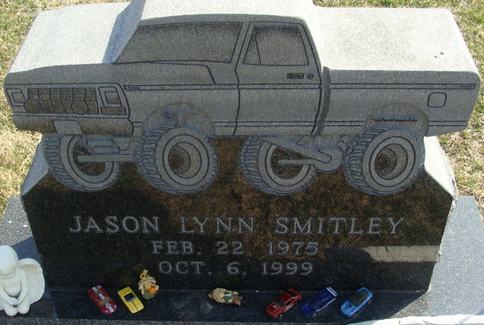
Photo by Alicia Kneuss

Jason Lynn Smitley, 24, of New Haven, was injured fatally at 4:34 p.m. Wednesday in an accident on I-69 near Anderson. He was employed the past two years as a machinist at Zollner in Fort Wayne and previously worked at Peyton Northern at Bluffton. He was a member of the 4x4 Club at Decatur, serving as its president.
He was born in Fort Wayne Feb. 22, 1975. His marriage Nov. 8, 1997 was to Stacey R. Vaughan, who survives.
In addition to his wife, he is survived by his mother, Kris Reed Smitley of Decatur, and a brother, Thomas L. Smitley of Decatur.
Services will be at 2:30 p.m. Sunday at Zwick & Jahn Funeral Home in Decatur, where calling will be today from 6 to 8 p.m., Saturday from 1 to 4 and 5 to 8 p.m. and Sunday for one hour prior to services.
Rev. Joe McInnis will officiate and burial will be in Decatur Cemetery.
Memorials to the family or to the donor's choice.

Bluffton News-Banner, Wells County, Indiana
October 7, 1999

**
Indiana, U.S., Death Certificates, 1899-2017
Name Jason Lynn Smitley
Gender Male
Race White
Marital Status Married
Age 24
Birth Date 22 Feb 1975
Birth Place Fort Wayne, Indiana
Death Date 6 Oct 1999; motorcycle accident
Death Place Pendleton, Madison, Indiana, USA
Death Registration Date 1999
Father Roger Smitley
Mother Kris R. Reed
Spouse Stacey R. Vaughan
Informant Stacey Smitley; wife; New Haven, Indiana
Burial October 10, 1999; Decatur Cemetery; Decatur, Indiana

