Homer F. Smitley
September 2, 1890 – June 8, 1956

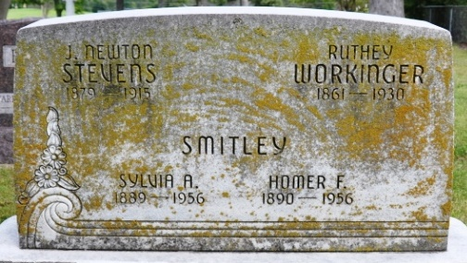
Photo by Deb Curry

HOMER SMITLEY DIES AT HOSPITAL
SERVICES MONDAY FOR BLUE CREEK TOWNSHIP NATIVE

Homer Smitley, 65, of South First Street, Decatur, a retired auto mechanic, died at 8 o'clock a.m. today at the Adams County Memorial Hospital He had been ill two years with a heart ailment and dropsy and had been serious for two months.
Mr. Smitley was born in Blue Creek Township Sept. 2, 1890, the son of John and Mary Ellen Foreman Smitley. His wife, Sylvia, is deceased.
Surviving are the following children: Mrs. John Stauffer, Bluffton; Gerald Smitley Duncan Falls, Ohio; Mrs. Thelma Kessler, Fort Wayne; Mrs. Donald Snell, Fort Wayne; Dale Smitley, Kokomo; Mrs., Doyle Gilbert, Decatur; two step-daughters, Mrs. Charles Ward and Mrs. Ward Brown; both of Decatur; three brothers, William Smitley, Decatur; Roy Smitley, Braden Beach, Florida and Ivan Smitley, Flint, Michigan; three sisters, Mrs. Frank Lautzenheiser, Monroe; Mrs. Blanche Applebee, Flint, Michigan and Mrs. Hazel Wisterman, Linden, Michigan; 16 grandchildren, five step-grandchildren and 12 great-grandchildren.
The body is at the Gillig and Doan Funeral Home in Decatur where friends may call after 2 p.m. Saturday. Services will be held at the funeral home at 1 p.m. Monday and at 2:00 p.m. at the Decatur Missionary church of which he was a member, Rev. Herald J. Welty and Rev. Benjamin Thomas, officiating. Burial will be in the Decatur Cemetery.

Berne Witness; Adams County, Indiana
Friday, June 8, 1956

**
Homer F. Smitley Dies This Morning
Funeral Services Monday Afternoon
Homer F. Smitley, 65, of 421 South First Street, retired auto mechanic, died at 8 o’clock this morning at the Adams County Memorial Hospital. He had been in failing health for two years of a heart condition and dropsy, and serious for the past two months.
He was born in Blue Creek Township Sept 2, 1890, a son of John N. and Mary Ellen Foreman-Smitley and was a lifelong resident of Adams County. His wife, Sylvia, preceded him in death.
Mr. Smitley was a member of the Decatur Missionary Church.
Surviving are four daughters, Mrs. John Stauffer of Bluffton, Mrs. Thelma Kessler and Mrs. Donald Snell of Fort Wayne, and Mrs. Doyle Gilbert of Decatur; two sons, Gerald Smitley of Duncan Falls, 0., and Dale Smitley of Kokomo; two stepdaughters, Mrs. Charles Ward and Mrs. Ward Bowman of Decatur; 16 grandchildren; five step grandchildren; 12 great-grandchildren; three brothers, William Smitley of Decatur, Roy Smitley of Bradon Beach, Fla., and Ivan Smitley of Flint, Mich., and three sisters, Mrs. Frank Lautzenheiser of Monroe, Mrs. Blanche Applebee of Flint, Mich., and Mrs. Hazel Listermann of Linden, Mich.
Funeral services will be conducted at 1:30 p.m. Monday at the Gillig & Doan Funeral Home and at 2 p.m. at the Decatur Missionary Church, the Rev. H. J. Welty and the Rev. Benj. G. Thomas officiating. Burial will be In the Decatur Cemetery. Friends may call at the funeral home after 2 p.m. Saturday until time of the services.
Decatur Daily Democrat, Adams County, Indiana
Friday, June 8, 1956

