Hilda E. (Hives) Smitley
March 14, 1914 – January 20, 1983

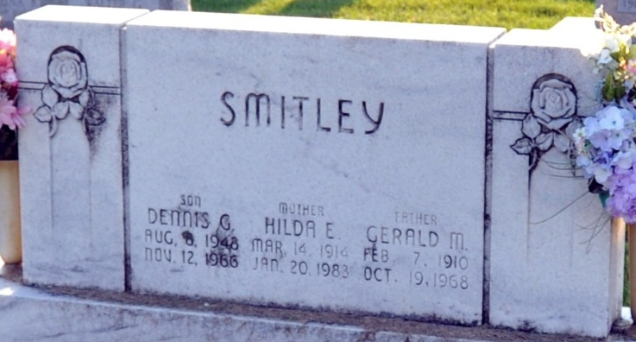
Photo by Deb Curry
Hilda E. Smitley
in the Indiana, U.S., Death Certificates, 1899-2017
Name Hilda E. Smitley
[Hilda E. Hives]
Gender Female
Race White
Marital Status Widowed
Age 68
Birth Date 14 Mar 1914
Birth Place England
Death Date 20 Jan 1983
Death Place Decatur, Adams, Indiana, USA
Death Registration Date 1983
Father Reginald Hives
Mother Edith Harvey
Informant Lorraine Villagomez; Decatur, Indiana
Burial January 22, 1983; Decatur Cemetery; Decatur, Indiana

