Henry A. Smitley
December 9, 1888 – August 28, 1950

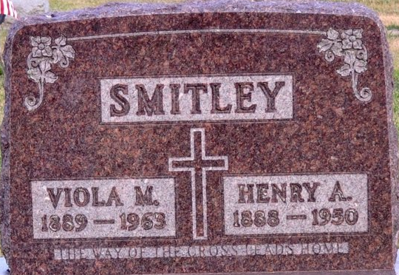
Photo by Deb Curry
HENRY SMITLEY, 61, CUSTODIAN OF FAIRGROUND, DIES
Henry A. Smitley, 61, of 134 Balyeat Avenue, custodian of the fairground for the past five years, died unexpectedly of heart disease about 8:45 a.m. today. The victim suffered a light attack Sunday night and a second attack occurred this morning. He was pronounced dead on arrival at the hospital.
The deceased, a native of Ross County, O., was born December 9, 1888, and was a son of the late Mr. and Mrs. John Smitley. He was a member of the Emanuel Lutheran Church.
Surviving are his widow, Viola; three sons, Junior at home, Harold of Portland, Ind., and Robert of 721 Glenn Street; four brothers, Rolie and Floyd Smitley of Decatur, Ind., Charles of Berne, Ind., and William of Sturgis, Mich.; a half-brother, Rev. C. Smitley of Florida; four sisters, Mrs. Bertha Foreman of Decatur, Mrs. Clara Edgell of Pleasant Mills, Ind., Mrs. Ella Speakman of Decatur RFD, and Mrs. Anna Collins of Oregon; and 10 grandchildren. Two children preceded him in death.
Funeral arrangements in charge of the Gamble-Alspach Funeral Home have not been completed.

Times Bulletin, Van Wert County, Ohio
Monday, August 28, 1950

**
OH Death Certificate #52078
Henry A. Smitley, resident of Van Wert, OH, male, white, married; Date/place of birth: Dec 9, 1888, Ohio
Father: John Smitley; Mother: Virginia Moss
not a vet, no SS#; Informant: Harold E. Smitley
Date/place of death: Aug 28, 1950, 134 Balyeat Ave, Van Wert, Van Wert, Ohio
Age: 61 yrs, 8 mon, 17 days; Cause of death: coronary occlusion
Burial date/place: 30 Aug 1950, Maplewood Cem, Decatur, Ind; Funeral director: Gordon H. Alspach

