Helen Irene Smith
May 22, 1916 – October 9, 1916

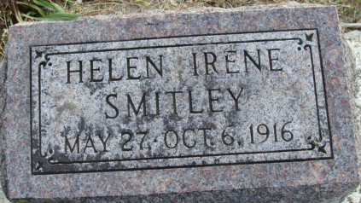
Photo by Alicia Kneuss

Helen Ireta Smitley was born May 22, 1916 and departed this life October 9, 1916, aged four months and seventeen days. Helen was the daughter of Henry and Viola Smitley. Her life was a brief one, but she has gone to be with the Savior. She will be greatly missed in the home, but heaven will be enriched by the transition.
She leaves to mourn the loss, the father, mother and two brothers, one brother having preceded her to the heavenly home, and a number of relatives. Also a grandfather and grandmother.
The tender bud will blossom into a full-blown rose in the Kingdom of our God.
(prayer)

Decatur Daily Democrat; Adams County, Indiana
October 14, 1916

**
DECATUR NEWS

The four-month-old baby of Mr. and Mrs. Henry A. Smitley is dead.

Fort Wayne Sentinel, Allen County, Indiana
October 10, 1916

**
Helen Irene Smitley from tree linda stevens Family Tree

Birth 22 May 1916 Decatur, Adams, Indiana, USA
Death 9 Oct 1916 Decatur, Adams, Indiana, USA
Father Henry Alvin Smitley (1888-1950)
Mother Viola Mary Roop (1889-1963)

