Gerald M. Smitley
February 7, 1910 – October 19, 1968

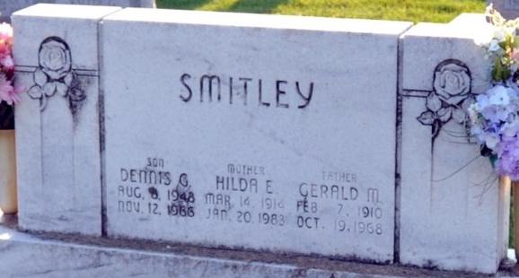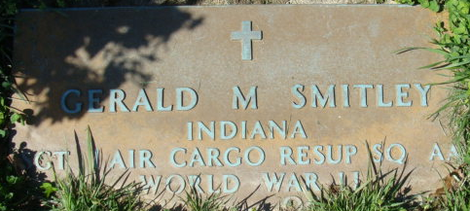
Photo by Deb Curry

Gerald M Smitley
in the Indiana, U.S., Death Certificates, 1899-2017
Name Gerald M Smitley
Gender Male
Race White
Marital Status Married
Age 58
Birth Date 7 Feb 1910
Birth Place Indiana
Death Date 19 Oct 1968
Death Place Decatur, Adams, Indiana, USA
Death Registration Date 1968
Father George Smitley
Mother Louisa Jane Clark
Spouse Hilda Hives
Informant Mrs. Gerald Smitley; wife; Decatur, Indiana
Burial October 22, 1968; Decatur Cemetery; Decatur, Indiana

