George W. Smitley, Jr.
September 7, 1922 – September 22, 1942

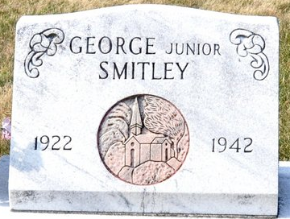
Photo by Deb Curry

Funeral Set for George Smitley
DECATUR, Ind., Sept. 23 – Funeral services for George Smitley, Jr., 20, of Decatur, who died yesterday at the hospital here of injuries suffered while working at the Decatur Castings Company, will be held Friday afternoon at 1:45 o'clock at the home and at 2:30 o'clock at the Union Church near Willshire, O. Burial will be in the Decatur Cemetery. The body was returned from the Black Funeral Home to the residence this afternoon.
Adams County Coroner J. Jerome Yager began an investigation of the accident yesterday. Smitley was burned Monday while lighting an oven where gas had apparently accumulated.

Adams County Historical Museum, Adams County, Indiana
February – November 1942 Scrapbook
Handwritten date: Wednesday, September 23, 1942

**
Indiana, U.S., Death Certificates, 1899-2017

Name George Smitley Junior
Gender Male
Race White
Age 20
Marital Status Single
Birth Date 7 Sep 1922
Birth Place Mercer Co Ohio
Death Date 22 Sep 1942
Death Place Decatur, Adams, Indiana, USA
Death Registration Date 1942
Father: George Smitley
Mother: Effie Yoder
Informant: Mrs. Smitley; Decatur, Indiana
Burial: September 25, 1942; Decatur Cemetery

