George W. Smitley
1872 - 1937

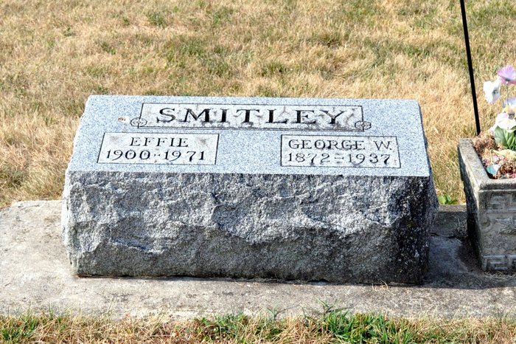
Photo by Deb Curry

George W. Smitley from tree Oliver/Smitley Family Tree
Birth 1872 Mercer, Ohio, USA
Residence 1920 Black Creek, Mercer, Ohio, USA
Marriage 8 Jan 1922 Mercer, Ohio, USA
Death 1937 Ohio, USA
Father Henry Smitley (1837-1913)
Mother Martha Ann Bannon (1834-1921)
Spouse Effie Yoder (1900-1971)
**

Ohio, U.S., County Marriage Records, 1774-1993

Name G W Smitley
Gender Male
Marriage Age 49
Birth Date abt 1873
Marriage Date 8 Jan 1922
Marriage Place Mercer, Ohio, USA
Father Henry Smitley
Mother Martha Bannon
Spouse Effie Yoder
Film Number 002366955
**

Ohio, U.S., Rutherford B. Hayes Presidential Center Obituary Index, 1810s-2016

Name George W Smitley
Death Age 64
Birth Date abt 1873
Death Date 1937
Death Place Ohio, USA
Newspaper Information Newspaper: Wilshire Herald, Newspaper Date: 04 Mar 1937, Newspaper Page: 1 Column: ; Repository: Brumback Public Library (Van Wert, Ohio); Years Available:

