Floyd Smitley
October 18, 1894 – December 16, 1964

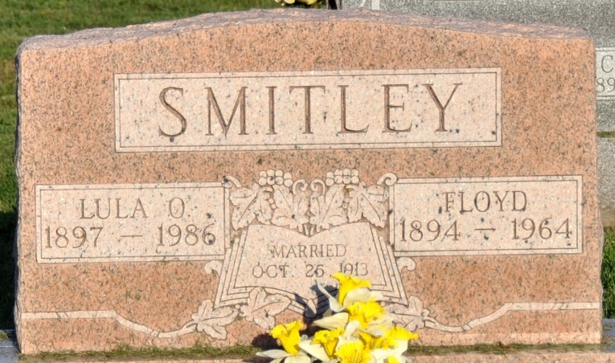
Photo by Deb Curry

Floyd Smitley
in the Indiana, U.S., Death Certificates, 1899-2017
Name Floyd Smitley
Gender Male
Race Caucasian (White)
Marital Status Married
Age 70
Birth Date 18 Oct 1894
Birth Place Ohio
Death Date 16 Dec 1964
Death Place R#2, Adams, Indiana, USA
Death Registration Date 1964
Father John Smitley
Mother Virginia Moss
Informant Lula Smitley; wife; Decatur, Indiana
Burial December 19, 1964; Decatur Cemetery; Decatur, Indiana

