Florence M. (Bowen) Smitley
August 31, 1905 – July 3, 1984

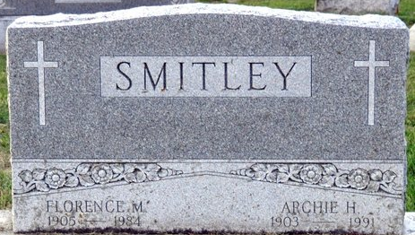
Photo by Deb Curry

Florence M. Smitley
in the Indiana, U.S., Death Certificates, 1899-2017
Name Florence M. Smitley
[Florence M. Bowen]
Gender Female
Race White
Marital Status Married
Age 78
Birth Date 31 Aug 1905
Birth Place Ohio
Death Date 3 Jul 1984
Death Place Decatur, Adams, Indiana, USA
Father Lambert W. Bowen
Mother Anna I. Harmon
Spouse Archie H. Smitley
Informant Archie Smitley; husband; Decatur, Indiana
Burial July 6, 1984; Decatur Cemetery; Decatur, Indiana

**
Name of Deceased, Florence M. SMITLEY, white
Married, wife of Archie H. SMITLEY; Residence; R # 5 Decatur, IN; Charge to Archie H. SMITLEY; Occupation, none given, B
Date of Birth; 31 August 1905, age 78 years; Birthplace; Wayne?, OH Place of Death; Adams Co., Memorial Hospital, Decatur, IN
Name of Father; Lambert W. BOWEN
Maiden Name of Mother; Anna I HARMON
Date of Funeral; 6 July 1984, Friday, 10:00 A.M; Services at; Funeral Home; Clergyman, Mr. or Mook or Mols W. HETRICK, Decatur, IN Religion of the Deceased; Protestant
Resided in State; Adams Co., In., 60 years
Certifying Physician, John E. Doan, M.D.; His address; Decatur, IN; Batesville Casket Co., IN; Burial, Decatur Cemetery.

WINTEREGG-LINE and HAGGARD FUNERAL HOME, Decatur, Adams Co., IN. Total # 688, Yearly # 44, Date of Entry, 4 July 1984

