Dennis G. Smitley
August 8, 1948 – November 12, 1966

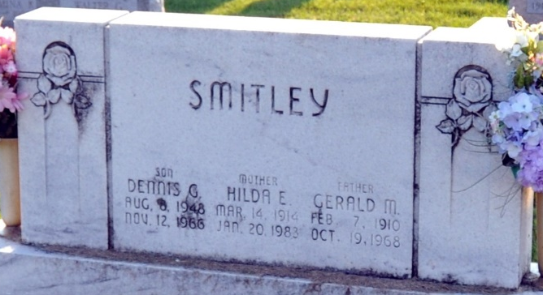
Photo by Deb Curry

STATE WRECKS KILL 15 ON THE WEEKEND

Indiana suffered its worst traffic weekend in more than a month, with at least 15 fatalities reported, 11 in 4 multiple- death crashes.
...Dennis Smitley, 18, Decatur, was killed and six other persons injured Saturday night in a two-car crash east of Lima, Ohio.
Unknown source

**
Ohio, U.S., Death Records, 1908-1932, 1938-2022
Name Dennis G Smitley
Gender Male
Race White
Marital Status Not married (Married)
Death Age 18
Birth Date Abt 1948
Death Date 12 Nov 1966
Death Place Allen, Ohio, USA
Certificate Number 81734
Inquest Hospital Public - Other
Inquest Questions Certifier: Coroner; Autopsy Performed?: Yes, Used For Certification;

**
Dennis G. Smitley from tree Smitley Family Tree WWII War Bride
Birth 8 Aug 1948 Decatur, Adams, Indiana, USA
Residence 1964 Decatur, Adams, Indiana, USA
Death 12 Nov 1966 Ohio, USA
Father Gerald M Smitley (1910-1968)
Mother Hilda Edith Hives (1914-1983)

