Clarence E. Smitley
March 1, 1901 – March 17, 1979

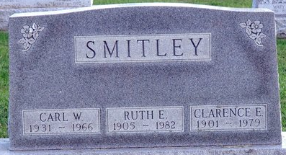
Photo by Deb Curry

Clarence E. (Shorty) Smitley, 78, of 210 North Seventh St., a retired Decatur city employee and superintendent of the Decatur Cemetery for 15 years, died at 7:50 Saturday at Parkview Memorial Hospital, Fort Wayne.
He was a member of the First United Methodist Church in Decatur.
Born in Jefferson Township on March 1, 1901, he was the son of William and Luella Marbaugh-Smitley, and was married on Feb. 28 1924 to Ruth E. Brown, who survives. They celebrated their 50th wedding anniversary on Feb. 28, 1974.
Also surviving are three sons, Vernon E., Royal Oak, Mich.; Robert L. and Alva W. Smitley, both of Decatur; two brothers, Archie, Decatur; and Chalmer Smitley, Berne; and two sisters, Mrs. Ralph (Marie) Christy, Berne; and Mrs. Alva (Florence) Lawson, Decatur. One son, Carl, died in 1966, and three brothers also preceded him in death.
Funeral services will be held Tuesday at 2 p.m. at the Winteregg-Linn & Haggard Funeral Home, with Pastor Earle E. Peer officiating. Burial will be in the Decatur Cemetery. Friends may call at the funeral home after 2 p.m. today.

Decatur Daily Democrat, Adams County, Indiana
Monday, March 19, 1979

