Carl Wayne Smitley
July 1, 1931 – September 1, 1966

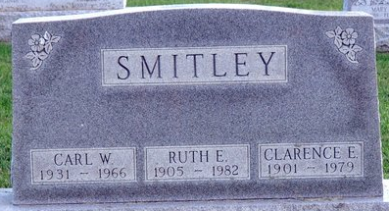
Photo by Deb Curry

Carl Wayne Smitley
in the Indiana, U.S., Death Certificates, 1899-2017
Name Carl Wayne Smitley
Gender Male
Race Caucasian (White)
Marital Status Married
Age 35
Birth Date 1 Jul 1931
Birth Place Indiana
Death Date 1 Sep 1966; plane crash
Death Place N Decatur, Allen, Indiana, USA
Death Registration Date 1966
Father Clarence E Smitley
Mother Ruth Brown
Informant Clarence Smitley; father; Decatur, Indiana
Burial September 3, 1966; Decatur Cemetery; Decatur, Indiana

