Calvin E. Smitley
November 3, 1929 – July 16, 2011

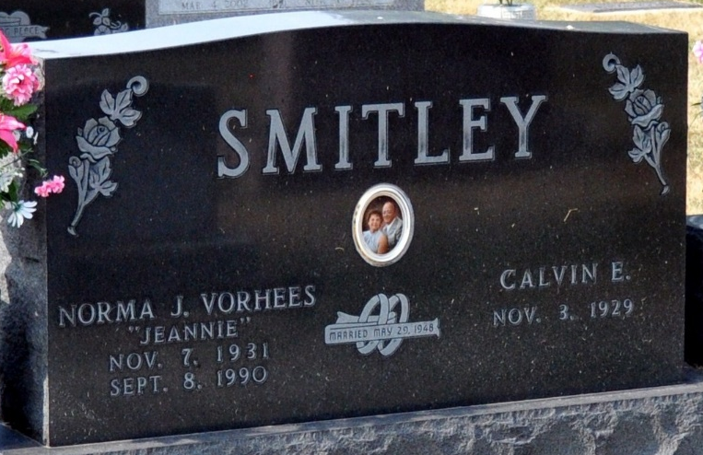
Photo by Deb Curry

Calvin E. Smitley 81, of Decatur, passed away on Saturday July 16, 2011 at his residence. Calvin was born on Nov. 3, 1929 in Mercer County, Ohio to the late George W. and Effie (Yoder) Smitley. He married Norma J. (Vorhees) on May 29, 1947. She passed away on September 8, 1990.
He retired in 1991 from the Dana Corporation in Fort Wayne after 43 ½ years of service. He was a member of Moose Lodge #1311 and Eagles Lodge.
Calvin is survived by one son Kenneth Smitley of Decatur, IN.; two daughters Nancy McLeland and Carla (Michael) Rapp both of Decatur, IN; one brother Herbert Smitley of Decatur, IN,; 10 grandchildren, 13 great grandchildren, and one great great granddaughter.
He is preceded in death by one daughter Gayla Whitman, one brother George Smitley Jr., one sister Ruth Wolfe, one grandson, and one great grandson.
Visitation will be on Monday July 18th from 4-8pm at Haggard Sefton and Hirschy Funeral Home. Funeral services will be on Tuesday July 19th at 10:00am also at the funeral home.
Burial will be at Decatur Cemetery. Pastor Chris Thurow will be officiating.

Haggard & Sefton Funeral Home, Adams County, Indiana
July 17, 2011

