Archie H. Smitley
August 1, 1903 – December 18, 1991

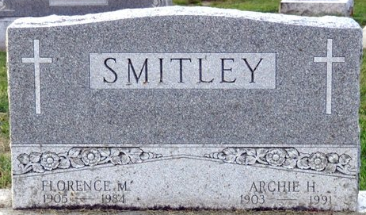
Photo by Deb Curry

Archie H Smitley
in the Indiana, U.S., Death Certificates, 1899-2017
Name Archie H Smitley
Gender Male
Race White
Marital Status Widowed
Age 88
Birth Date 1 Aug 1903
Birth Place Adams County, Indiana
Death Date 18 Dec 1991
Death Place Berne, Adams, Indiana, USA
Death Registration Date 1991
Father William N Smitley
Mother Emma Marbaugh
Informant Iona Zuercher; daughter; Berne, Indiana
Burial December 21, 1991; Decatur Cemetery; Decatur, Indiana

