Wilma Louise (Grove) Smith
June 6, 1923 – January 6, 1952

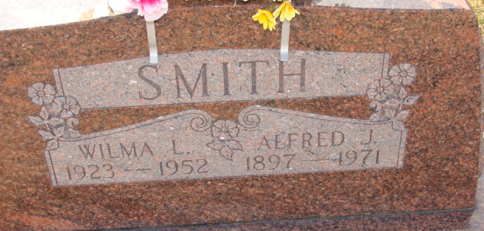
Photo by Alicia Kneuss

YOUNG MOTHER DIES ON SUNDAY
Mrs. Wilma Smith, 28, of West of Monroe Dies Unexpectedly
Decatur, Jan. 7 - Mrs. Wilma Grove Smith, 28, died unexpectedly at 7 a.m. yesterday at her home two miles west and 1/2 mile south of Coppess Corners after a year's illness.
Surviving are the husband, Alfred J. Smith; a daughter, Sharon Elizabeth, at home; her father, John Grove, near Decatur; two brothers, Victor and Gerald Grove, Decatur and a sister, Mrs. William Harvey.
The body was brought here to the Zwick Funeral Home, where friends may call. Services will be conducted at 2 p.m. Tuesday at the funeral home, the Rev. H. H. Meckstroth officiating. Burial will be in Decatur Cemetery.
Mrs. Smith was born in Blue Creek Township June 6, 1923. She graduated from the Monroe High School with the class of 1941 and on Feb. 3, 1947 was married to Alfred J. Smith. She spent most of her life in this community.
Though not well for some time, Mrs. Smith was up and around as usual and her death Sunday was very sudden and apparently caused by a heart attack.

The Berne Witness; Adams County, Indiana
Monday, January 7, 1952
**
Wilma Louise Grove from tree HufferFamilies2013June28

Birth 6 Jun 1923 Adams, Indiana, USA
Residence 1930 Adams, Indiana, USA
Father John Frank Grove (1894-1968)
Mother Mahala A Hays (1897-1930)

