William Sherman Smith
February 11, 1871 – September 19, 1955

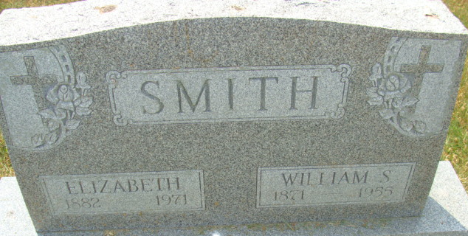
Photo of Alicia Kneuss

SMITH
William S. Smith, 84, of Decatur, Ind., father of Max Smith of Van Wert, died Monday at the Adams County Memorial Hospital in Decatur.
He is survived by his widow, Elizabeth, six daughters, three sons, two brothers, 30 grandchildren and seven great-grandchildren.
Services will be held at 2 p.m. Thursday at the Gillig & Doan Funeral Home in Decatur. Burial will be in the Decatur Cemetery.
Van Wert Times Bulletin, Van Wert County, Ohio
September 20, 1955

**
Indiana, U.S., Death Certificates, 1899-2017
Name William Sherman Smith
Gender Male
Race White
Age 84
Marital Status Married
Birth Date 11 Feb 1871
Birth Place Huntington Co Indiana
[Servia, Wabash County, Indiana, USA]
Death Date 19 Sep 1955
Death Place Decatur, Adams, Indiana, USA
Death Registration Date 1955
Father: Samual Smith
Mother: Harriet Archer
Informant: Mrs. Elizabeth Smith; Decatur, Indiana
Burial: September 22, 1955; Decatur Cemetery; Decatur, Indiana

