William C. Smith
August 24, 1888 – January 11, 1971

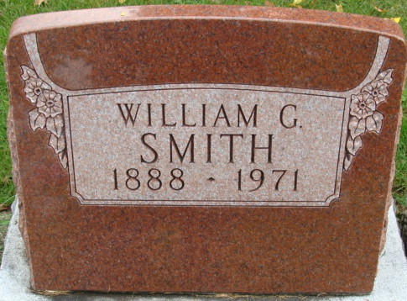
Photo by Alicia Kneuss

William C. Smith Dies at Hospital
William C. Smith, 82, of Decatur route 3, died at 8:47 p.m. Monday at the Adams County Memorial Hospital, following an illness of two years. He was born in Dixon, O., Aug. 24, 1888, a son of John and Nettie Hart-Smith, and was married to Nora Dishong in December of 1909. His wife preceded him in death March 19, 1963.
Mr. Smith was a former employee of the Maier Hide & Fur Co. in this city.
Surviving are one son, James G. Smith of Decatur; three daughters, Mrs. Lawrence (Nettie) Jacobs and Mrs. William (Ollie) Huss, both of Decatur, and Mrs. Jay (Esther) Osborn of Decatur route 3; a brother, John Smith of Decatur route 5; a half-sister, Mrs. Allen (Sarah) Howdyshell of Decatur; 18 grandchildren and 27 great-grandchildren.
Funeral rites will be held at 1:30 p.m. Thursday at the Zwick Funeral Home, with Rev. L. T. Norris officiating. Burial will be in the Decatur Cemetery. Friends may call after 2 p.m. Wednesday until time of the services.

Decatur Daily Democrat, Adams County, Indiana
Tuesday, January 12, 1971

