Wilfred S. Smith
July 29, 1866 – August 8, 1949

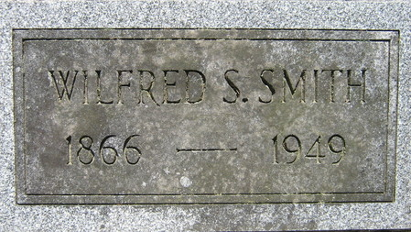
Photo by Deb Curry

W. S. SMITH, 83 FORMER MONROE BANKER IS DEAD
Wilford S. (Willie) Smith 83, prominent Monroe resident and businessman for many years, died this morning at 2:30 o’clock at the Adams County Memorial Hospital. He had been critically ill for three weeks and ailing for six months. Mr. Smith spent many years of his life in Monroe but resided with his son, Clarence in Preble Township, for the past few months.
Mr. Smith was the first president and cahier of the Bank of Monroe. He accepted this post in 1916. He and George Durfee of Fort Wayne organized the Monroe Lumber Company in 1908. He was at one time a member of the Monroe town board and was a trustee of the Monroe Methodist Church for many years.
The deceased was born at Marshfield, Vermont, July 29 1866, the son of Theophilus and Sabrina Parker Smith. He was married to Electa Macy in 1887. He and his wife came to Adams County in 1892 and he has resided in this community since. His wife proceeded in death in 1938.
Surviving are two sons, Clarence of Preble Township, a former banker at Preble, and George, of Columbus, Ohio. There is one daughter, Mrs. Clyde Hendricks of Fort Wayne, four granddaughters and two great granddaughters survive. Two sisters and one granddaughter are deceased.
The body was taken to the Black Funeral Home at Decatur were it may be viewed after 7:00 p.m. today. The funeral will be at 1:30 p.m. Sunday at the funeral home and at 2:00 p.m. at the Monroe Methodist Church. Rev. Elbert Morford, former pastor, will officiate, assisted by the present pastor, Rev. Hall. Burial will be in the Decatur Cemetery.

Decatur Daily Democrat, Adams County, Indiana
August 8, 1949

