Wanda M. (Baxter) Smith
May 20, 1927 – June 18, 2020

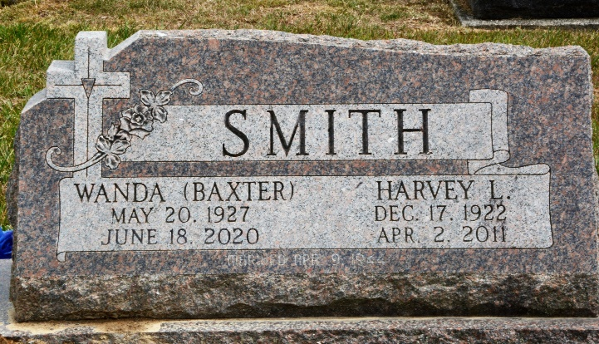
Photo by Deb Curry

Wanda M. Smith, 93, of Decatur, IN, former longtime resident of Monroe, passed away on Thursday, June 18, 2020, at Adams Woodcrest. She was born in Adams County, IN, on May 20, 1927, the daughter of the late William F. and Florence (Snell) Baxter. On April 9, 1944, she married Harvey L. Smith and after 66 years he preceded her in death on April 2, 2011.
She was a member of St. John Family Worship Center in Vera Cruz and also attended St. Luke Church in rural Adams County. Wanda was the co-owner, along with her late husband of Smith Trailer Sales, which started in 1959 behind their home in Monroe and is still in operation to this day.
She is survived by her 2 sons, Rodney L. (Lori) Smith of Fort Wayne and Roger W. (Pamela) Smith of Monroe; 2 daughters, Arvilla (Thomas) Ripley of Lexington, KY and Janet Omspach of Monroe; a daughter-in-law, Donna J. Smith of Decatur; 11 grandchildren, 20 great-grandchildren, and 2 great-great grandchild.
She was also preceded in death by a son, Ronald L. Smith on September 6, 2013; 2 brothers, Bob Baxter and Bill Baxter; 3 grandchildren.
A Private Family Burial was held in the Decatur Cemetery and Pastor Don Rentschler officiated. Due to COVID-19, a memorial gathering will be held later this fall.

Haggard & Sefton Funeral Home, Adams County, Indiana
June 19, 2020

