Vickie Faye Smith
January 12, 1957 – June 1, 1963

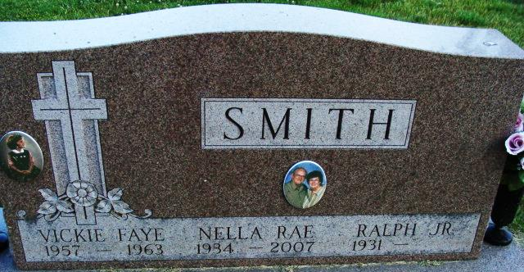
Photo by Alicia Kneuss

Rites Friday for Vickie Faye Smith

Funeral services for Vickie Faye Smith, six-year-old daughter of Mr. and Mrs. Ralph Smith, Jr., who died Tuesday night after a long illness of leukemia, will be held at 2 p.m. Friday at the First Methodist church. The Rev. A. C. Underwood will officiate, and burial will be in the Decatur cemetery.
Friends may call at the Winteregg-Linn Funeral Home until 12 noon Friday, after which the body will lie in state at the church until time of the services. Pallbearers will be Kenneth Jennings, Dick Heller, Jr., Charles Stonestreet and Norman Steury.

Berne Library Heritage Room, Adams County, Indiana
Obit Book
Handwritten date: Thursday, June 3, 1963

**
Vickie Faye Smith Dies Tuesday Night

Six-year-old Vickie Faye Smith lost her long, courageous battle for life Tuesday night when death ended her suffering at 11:17 o’clock Tuesday night at the Lutheran hospital.
The little child of Mr. and Mrs. Ralph Smith, Jr., 1135 West Marshall Street, had been suffering from leukemia for the past 16 months. Her condition became critical about one month ago as she slowly weakened from the ravages of the disease.
The child’s valiant battle for life had evoked the sympathy of hundreds of people in Decatur and area, and Vickie had been the recipient of an untold number of cards from well-wishers.
She was born in Decatur Jan. 12, 1957, the daughter of Ralph, Jr., and Nella Potter-Smith. She was a member of the First Methodist Church.
Surviving are the parents; one brother, Allen Smith, at home; the grandparents, Mr. and Mrs. Ralph Smith, Sr., of Decatur, and Mr. and Mrs. John Gentry of Dayton, Tenn., and great-grandparents, Mr. and Mrs. E. Y. Hall of Dayton, Tenn.
Final rites will be conducted at 2 p.m. Friday at the First Methodist Church, the Rev. A. C. Underwood officiating. Burial will be in the Decatur Cemetery. The body was removed to the Winteregg-Linn Funeral Home, where friends may call after 7 p.m. today until time of the services.

Berne Library Heritage Room, Adams County, Indiana
Adams County Obits 1962-1964
Handwritten date: Wednesday, June 12, 1963

