Veda V. (Smith) Smith
April 2, 1914 – April 4, 2003

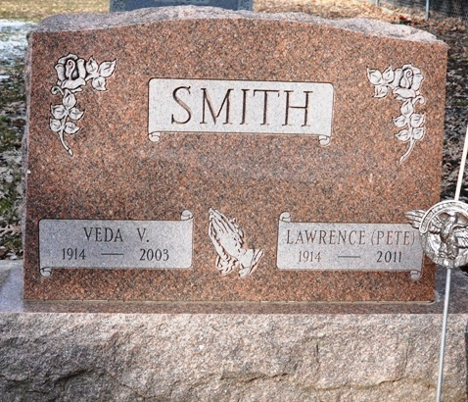
Photo by Deb Curry

Veda V. Smith, 89, died Friday at home. Born in Adams County, she had worked at Murphy's Five & Dime and Decatur Industries and retired in the mid-1970s from CTS of Berne.
Surviving are her husband, Lawrence "Pete" R.; four daughters, Lorna Fitzgerald of Parrish, Fla., Betty Brooks of Estero, Fla., Dorothy Poling of Decatur and Donna Lasseter of Atlanta; a brother, Roy Smith of Evansville; a sister, Ruth Johns of Van Wert, Ohio; six grandchildren; and seven great-grandchildren.
Services at 11 a.m. Wednesday at St. Mark's United Methodist Church, Decatur, with calling one hour before services. Calling also from 1 to 4 and 6 to 8 p.m. Tuesday at Haggard & Sefton Funeral Home, Decatur. Burial in Decatur Cemetery.
Memorials to Family Hospice of Northeast Indiana or the church.

Journal-Gazette, Allen County, Indiana
April 6, 2003

