Thelma J. (Johnson) Smith
November 16, 1906 – November 2, 1996

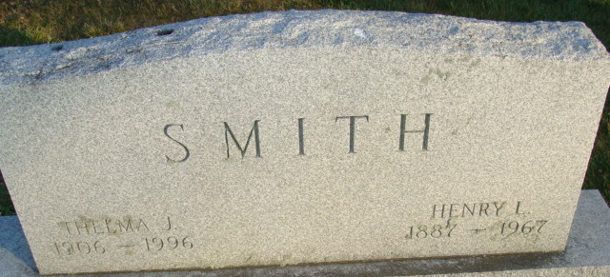
Photo by Alicia Kneuss

Thelma J. Smith, 89, of Berne died Saturday in Swiss Village. The Monroe native was the widow of Harry L., who died in 1967 and was former owner of a credit union in Defiance, Ohio.
Surviving is a sister-in-law, Helen M. Johnson of Decatur.
Services are private in Haggard & Armes Funeral Home, Decatur.
Memorials are to Swiss Village.

News-Sentinel, Allen County, Indiana
Monday, November 4, 1996
**
Indiana, U.S., Death Certificates, 1899-2017
Name Thelma J Smith
[Thelma J Johnson]
Gender Female
Race White
Marital Status Widowed
Age 89
Birth Date 16 Nov 1906
Birth Place Monroe, Indiana
Death Date 2 Nov 1996
Death Place Berne, Adams, Indiana, USA
Death Registration Date 1996
Father Sylvester Johnson
Mother Lula Hendricks
Informant Helen Johnson; sister-in-law; Decatur, Indiana
Burial November 4, 1996; Decatur Cemetery; Decatur, Indiana

