Susannah M. (Andrews) Smith
October 5, 1841 – February 26, 1896

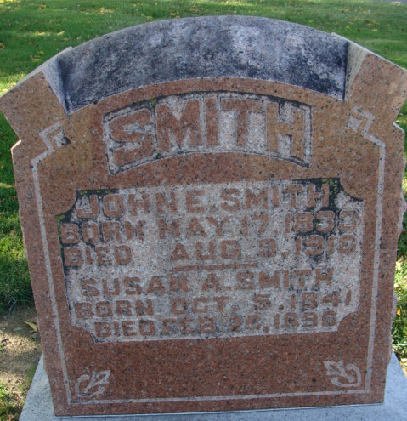
Photo by Alicia Kneuss

Mrs. John E. Smith died at her home on Eighth Street last Friday morning, after a lingering illness with consumption. The funeral was held from the Methodist Church last Sabbath morning.
She was sixty-five years of age, and has lived here for many years, and was known to everyone. She was one of the promoters and organizers of the Rebekah Lodge and has filled every official position in that order.
She leaves a husband to mourn her death.

Decatur Democratic Press; Adams County, Indiana
A weekly newspaper
Thursday, February 27, 1896
**
Susannah M Andrews from tree Binkley/O'Neal Family Tree
Birth 5 Oct 1841 Indiana, USA
Marriage 8 Sep 1864 Indiana, USA
Residence 1880 Decatur, Adams, Indiana, USA
Death 26 [sic] Feb 1896 Indiana, USA
Father Thomas Wallace Andrews (1818-1883)
Mother Deborah Grim (1819-1891)
Spouse John E Smith (1833-1910)

