Sarepta Mary (Butcher) Smith
May 18, 1901 – April 16, 1990

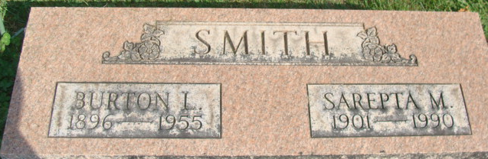
Photo by Alicia Kneuss

Sarepta Mary Smith, 88, Roanoke, died Monday in Lutheran Hospital. The Bryant native was the widow of Burton, who died in 1955.
Surviving are daughters, Deloris Bradley of Roanoke, and Rosemary Dernier and Barbara Besancon, both of Fort Wayne; 16 grandchildren; 34 great grandchildren and 27 great-great grandchildren.
Services are 1 pm Friday in D.O. McComb & Sons Foster Park Funeral Home, 6301 Fairfield Ave., where calling is 2 to 5 and 7 to 9 pm tomorrow. Burial will be in Decatur Cemetery.
Preferred memorials are gifts to Visiting Nurse Service & Hospice Foundation.

Journal-Gazette; Allen County, Indiana
April 18, 1990

**
Indiana, U.S., Death Certificates, 1899-2017
Name Sarepta Mary Smith
[Sarepta Mary Butcher]
Gender Female
Race White
Marital Status Widowed
Age 88
Birth Date 18 May 1901
Birth Place Bryant, Indiana
Death Date 16 Apr 1990
Death Place Fort Wayne, Allen, Indiana, USA
Death Registration Date 1990
Father Charles Butcher
Mother Louella Betz
Informant Barbara Besancon; daughter; Fort Wayne, Indiana
Burial April 20, 1990; Decatur Cemetery; Decatur, Indiana

