Sarah Matilda (Evans) Smith
September 10, 1861 – December 19, 1945

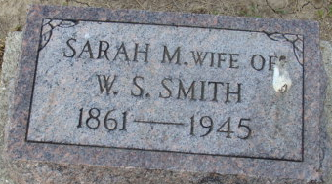
Photo by Alicia Kneuss

Sarah Matilda Evans Smith from tree COLLIER Family Tree
Birth 10 Sep 1861 Knoxville, Knox, Tennessee, USA
Marriage 16 Nov 1878 Tipton, Tipton, Indiana, USA
Residence 1930 Lenox, Ashtabula, Ohio, USA
Death 19 Dec 1945 Decatur, Adams, Indiana, USA
Father Absolom Powell Evans (1832-1917)
Mother Luvicia Catherine Evans (1835-1916
Spouse Wiley Cicero Smith (1852-1925)

