Sarah Ann (Roe) Smith
July 23, 1870 – January 24, 1947

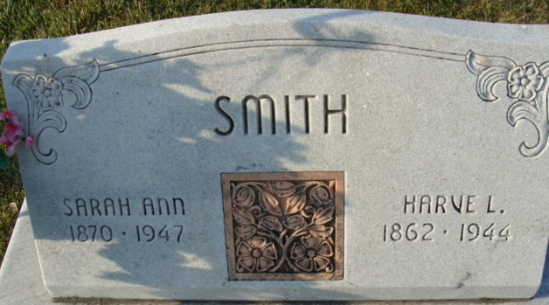
Photo by Alicia Kneuss

Sarah Ann Smith
in the Indiana, U.S., Death Certificates, 1899-2017
Name Sarah Ann Smith
[Sarah Ann Roe]
Gender Female
Race White
Marital Status Widowed
Age 76
Birth Date 23 Jul 1870
Birth Place Indiana
Death Date 24 Jan 1947
Death Place Adams, Indiana, USA
Death Registration Date 1947
Father Isiac Roe
Mother Kathryn Smith
Spouse Harvey Smith
Informant Ocie Durr; Decatur, Indiana
Burial January 28, 1947; Decatur Cemetery; Decatur, Indiana

