Samantha Jane (Patterson) Smith
September 29, 1842 – August 24, 1887

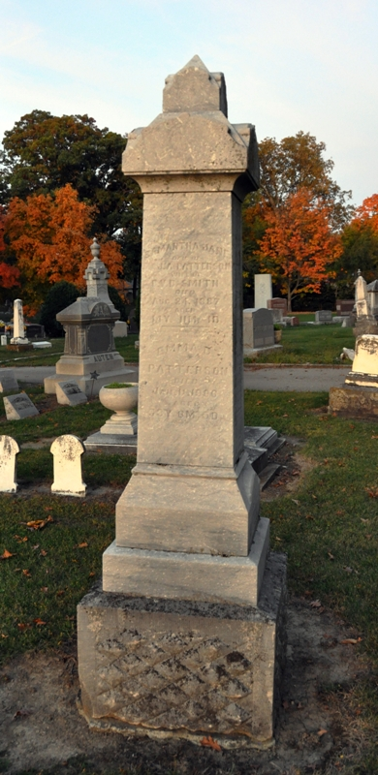
Photo by Deb Curry

Samantha Jane Patterson from tree Sandra Lois Parks Family
Birth 29 Sep 1842
Marriage 6 May 1862 Decatur, Adams, Indiana, USA
Death 29 Sep 1887(sic)
Father Samuel Patterson
Spouse Preston Van Buren Smith (1835-1917)

