Ruth Lorine (Hess) Smith
May 1, 1928 – January 9, 2019

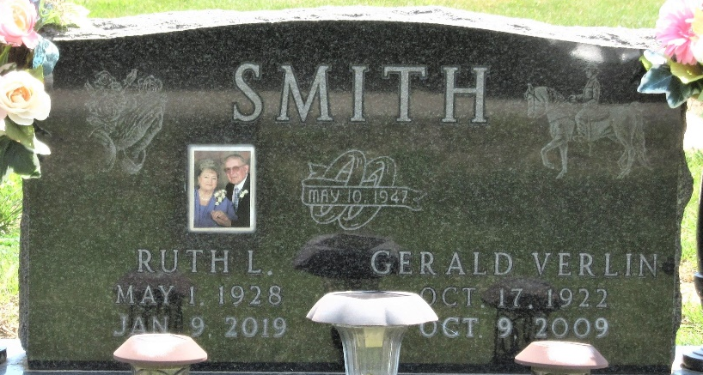
Photo by PLS

Ruth Lorine Hess
in the Indiana, U.S., Birth Certificates, 1907-1944
Name Ruth Lorine Hess
Gender Female
Birth Date 1 May 1928
Birth Place Union, Adams, Indiana, USA
Father Harold R. Hess; age 20
Mother Margaret M Hirschey; age 14; 1st child
Certificate Number 20401
Roll number 40474_357832
Volume Range 41 - 45

**
Ruth Smith
in the Ohio, U.S., Death Records, 1908-1932, 1938-2022
Name Ruth Smith
Gender Female
Death Age 91
Birth Date 1 May 1928
Death Date 2019
Death Place Van Wert
Mother Hirshey
Certificate Number 2019002873

