Ruth H. (Myers) Smith
November 26, 1894 – March 22, 1978

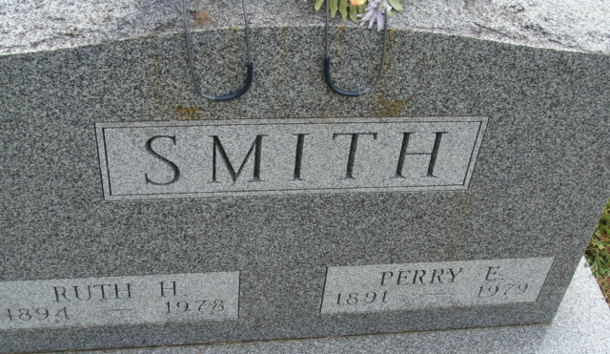
Photo by Alicia Kneuss

H Ruth Smith
in the Indiana, U.S., Death Certificates, 1899-2017
Name H Ruth Smith
[H Ruth Myers]
Gender Female
Race White
Marital Status Married
Age 83
Birth Date 26 Nov 1894
Birth Place Indiana
Death Date 22 Mar 1978
Death Place Fort Wayne, Allen, Indiana, USA
Death Registration Date 1978
Father Simon Myers
Mother Sadie Murrey
Spouse Perry Smith
Informant Perry Smith; Fort Wayne, Indiana
Burial March 25, 1978; Decatur Cemetery; Decatur, Indiana

