Ruth Elaine Smith
February 5, 1938 – February 5, 1946

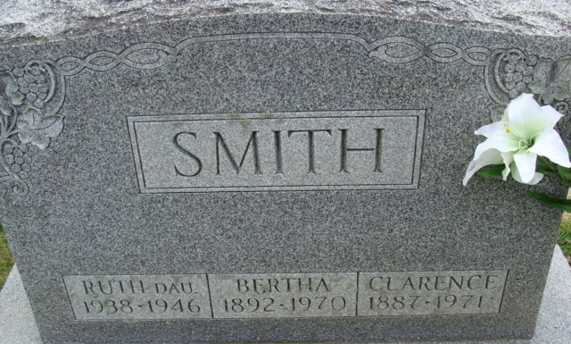
Photo by Alicia Kneuss

Ruth Elaine Smith Dies Monday Night
Funeral Service Thursday Afternoon
Ruth Elaine Smith, 8, daughter of Mr. and Mrs. Clarence Smith, died at 11:15 o'clock Monday night at the home of her parents in Preble, where her father is cashier of the Preble bank. Death was caused by an infantile heart lesion, following a short illness.
The child was born in Decatur February 5, 1938, the daughter of Clarence and Bertha Fuhrman Smith, and was the only child in the family.
She was a pupil in the Election School in Kirkland Township, and a member of the First Evangelical Church in this city.
Surviving in addition to the parents are a grandfather, Wilford Smith of Monroe and a grandmother, Mrs. J. A. Fuhrman of Decatur.
Funeral services will be held at 1 p.m. Thursday at the home and at 1:30 o'clock at the First Evangelical Church, with the Rev. George S. Lozier of South Bend officiating. Burial will be in the Decatur Cemetery. The body will be removed from the Black Funeral Home to the residence, where friends may call after 2 p.m. Wednesday.

Decatur Daily Democrat, Adams County, Indiana
February 5, 1946

