Catharine (Rawley) Smith-Rugg
October 26, 1836 – October 3, 1923

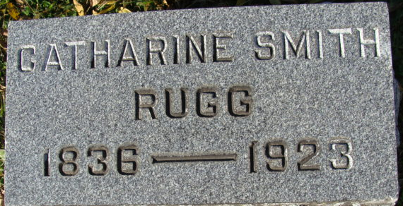
Photo by Alicia Kneuss

MRS. CATHERINE RUGG, A PIONEER OF COUNTY, DIES - One of Oldest Residents of City Died At Home of Son, W. R. Smith, Today. - Nearly 87 Years Old - Came at Adams County with Parents When County Was Still Wilderness.
Catherine Rowley Rugg, 86, a beloved pioneer of Adams County and one of the oldest residents of Decatur, died at the home of her son, W. R. Smith, 325 North Third Street, at 12:15 o'clock this morning. Death was due to infirmities of old age and paralysis and had been bedfast for the past four weeks.
Mrs. Rugg's home was on Ninth Street, but she had been at her son's home for the last six weeks. Prior to that time, she lived alone part of the time and spent the remainder of the time with her children. Until recently Mrs. Rugg had been blessed with remarkably fine health for a person of her age. She still has all of her natural teeth, only one of them having been filled.
Catherine Rowley, daughter of Tilmon and Elizabeth Rowley, was born in Clark County, Ohio, October 26th, 1836. She came to Adams County Indiana, with her parents when she was a small child. At that time this county was unimproved, and it was necessary for the elder Rowley’s to cut roads through the wilderness. They resided in Root Township. Catherine was married to Franklin B. Smith, who came to Adams County with his parents from Pennsylvania. To this union were born eight children, four of whom lived to maturity. The four who are still living are W. R. Smith, of this city; M. L. Smith, of Berne; Mrs. V. L. Shaffer, of Monroeville; and Mrs. J. T. Dailey, east of this city. Mr. Smith died in 1871.
On June 20, 1876, Mrs. Smith was married to Jay Rugg, a son of Samuel Rugg, one of the founders of the city of Decatur. To this union were born two children, one of whom died in infancy, and the other, Mrs. Gertrude Cashen, died last spring. Mr. Rugg died on November 1, 1896. Mrs. Rugg resided on her farm in Root Township for several years after the death of her husband, but finally moving to this city.
Mrs. Rugg was a member of the First Methodist Episcopal Church, of Decatur. She was loved by all who knew her, and she was regarded as one of the finest ladies of the community.
Besides the four children, named above, Mrs. Rugg is survived by one brother, Jacob Rowley, south of this city, and one sister, Mrs. N. J. Neher (Neber?), of Grand Rapids, Michigan.
Funeral services will be held from the First Methodist Church at 2 o'clock Friday afternoon unless circumstances make it necessary to change the time. The Rev. U. S. A. Bridge, pastor of the church, will have charge of the services. Burial will be made in the Maplewood Cemetery.

Decatur Daily Democrat, Adams County, Indiana
Wednesday, October 3, 1923

**
Indiana, U.S., Death Certificates, 1899-2017
Name Catharine Rugg
[Catharine Rawley]
Gender Female
Race White
Age 86
Marital Status Widowed
Birth Date 26 Oct 1836
Birth Place Clarks Co Ohio
Death Date 3 Oct 1923
Death Place Decatur, Adams, Indiana, USA
Death Registration Date 1923
Father: Tilman Rawley
Mother: Elizabeth Harshbarger
Spouse: Jay Rugg
Informant: W. R. Smith; Decatur, Indiana
Burial: October 5, 1923; Decatur Cemetery

