Rowena Beryl (Merriman) Smith
February 20, 1906 – October 15, 1995

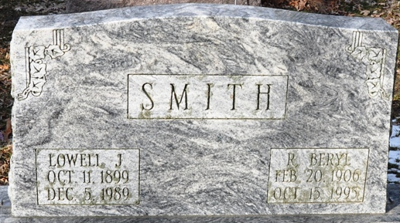
Photo by Deb Curry

Rowena Beryl Smith
in the Indiana, U.S., Death Certificates, 1899-2017
Name Rowena Beryl Smith
[Rowena Beryl Merriman]
Gender Female
Race White
Marital Status Widowed
Age 89
Birth Date 20 Feb 1906
Birth Place Adams County, Indiana
Death Date 15 Oct 1995
Death Place Decatur, Adams, Indiana, USA
Death Registration Date 1995
Father William P Merriman
Mother Anis Victoria Riley
Informant G. Medford Smith; son; Decatur, Indiana
Burial October 19, 1995; Decatur Cemetery; Decatur, Indiana

