Romaine E. (Fry) Smith
November 7, 1922 – August 29, 2014

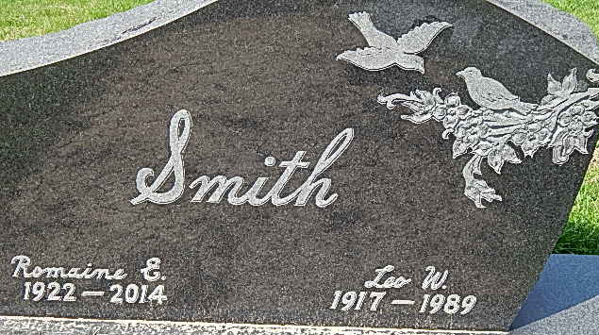
Photo by Alicia Kneuss

Romaine E Smith was born in Fort Wayne, Indiana. She was married to Leo Walter Smith and was a homemaker and a member of Saint Andrews Lutheran Church of Franklin, Tennessee.
Romaine was 91 years old and a resident of Springhill, Tennessee, formerly of Van Wert, Ohio and Woodstock, Georgia, when she passed away peacefully on August 29, 2014 at NHC of Columbia, Tennessee.
Preceded in death by her husband, her son Larry Smith, grandson Andrew Howe, two sisters and a brother, she is survived by a married daughter; two married sons; a daughter-in-law; nine grandchildren; nineteen great-grandchildren; six 2nd-great-grandchildren; a sister; and several nieces and nephews.
Burial was in Decatur Cemetery at Decatur, Indiana.
The Tennessean, Nashville, Tennessee
September 3, 2014

**
Romaine E. Smith, 91, of Springhill, TN, passed away peacefully August 29, 2014 at NHC of Columbia, TN. Surviving are her daughter, Joy (Joe) Spoto; son, Jack (Kathy) Smith; son, Randy (Tiffany) Smith; daughter-in-law, Cheryl Smith; 9 grandchildren; 19 great-grandchild-ren; 6 great-great-grandchildren; sister, Jean Lahrman of Fort Wayne; several nieces and nephews. Romaine was preceded in death by husband, Leo Walter Smith; son, Larry Smith; grandson, Andrew Howe, 2 sisters and 1 brother.

News-Sentinel, Allen County, Indiana
Wednesday, September 3, 2014

**
Indiana, Birth Certificates, 1907-1940
Name: Ester Romaine Fry
Gender: Female
Birth Date: 7 Nov 1922
Birth Place: Jefferson, Allen, Indiana, USA
Registration Year: 1922
Father: Ralph M Fry
Mother: Verona Mc Heinfeldt
Certificate Number: 55820
Roll Number: 023
Agency: Indiana State Board of Health
Volume Range: 111 - 115

