Roberta J. “Bobby” (Calvert) Smith
February 9, 1928 – November 22, 2020

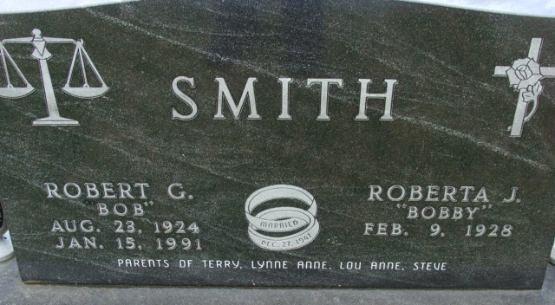
Photo by Alicia Kneuss

Roberta (Bobby) Jeanne Calvert Smith, 92 of Decatur, passed away from Covid-19 at Woodcrest Nursing Center on November 22, 2020. She was born in Fort Wayne on Feb 9, 1928 to Paul and Mary (Martin) Calvert, who passed when Bobby was age 8. Bobby was lucky to have a second mom, beloved Paula Schaper Calvert, who helped raise her.
She was united in marriage to the love of her life, Robert G. Smith, who preceded her in death Jan. 15, 1991 after 43 wonderful years of marriage. They enjoyed camping, traveling, spending time on their “farm.” She was a servant to all she had contact with.
Bobby was a member of First United Methodist Church, where she was involved in many things; she taught Sunday and Bible School, lead Youth Choir, Sang in Choir, played Bells, served on Worship and PPR committees, helped in church office, prayer chain, calling on shut-ins, Hope Chest Board, Former President United Methodist Women, Funeral Dinners and delivered for Operation Help.
Bobby loved to sing, play piano and organ. She enjoyed sewing, crocheting, quilting, crafts, reading, and exercise class. Bobby was a professional volunteer which included: American Cancer Society, Blood Mobile, Angel Tree, American Legion Auxiliary, Republican Party, Lakeside and Woodcrest helper, transported patients to chemotherapy in Ft Wayne, Head Start, Meals on Wheels,
Grandma Bobby loved her grandchildren and great grandchildren and having sleepovers and playing Monopoly, card games, going to the zoo and for ice cream and picnics.
She is survived by sons, Terry R. and Steven Lee (Jan) Smith; daughter Lou Anne (Jon) Stevens, sister, Janet (James) Kirsch; grandchildren Amanda (Chad) Poling, Sarah (Chad) Johnson and Jon A. (Tracy) Stevens, Carly (Agatha) Smith, Jordan (Brittaney) Smith and 8 great grandchildren, 4 step- great grandchildren, 3 step great-great grandchildren, and nieces and nephews and her 5 Calvert cousins.
She was preceded in death by daughter Lynne Anne Smith in 1953, her parents Paul, Mary and Paula Calvert, sister-in-law and brother-in-law, Annie and Barney Sparks, nieces, Julie Forgey and Jill Sheagley.
A private family service will be held at Haggard-Sefton-Hirschy & Zelt Funeral Home, with burial following in Decatur Cemetery.
Memorials may be given to First United Methodist Church Flower fund or Music Ministry.

Haggard & Sefton Funeral Home, Adams County, Indiana
November 23, 2020

