Robert G. Smith
August 23, 1924 – January 15, 1991

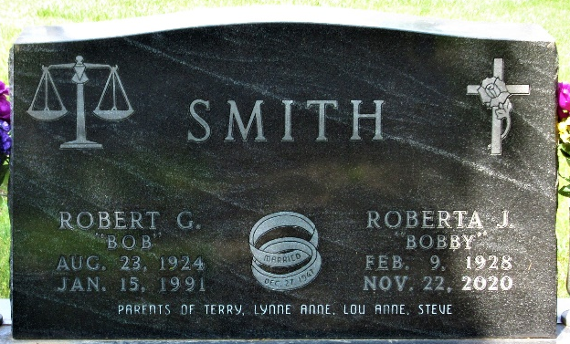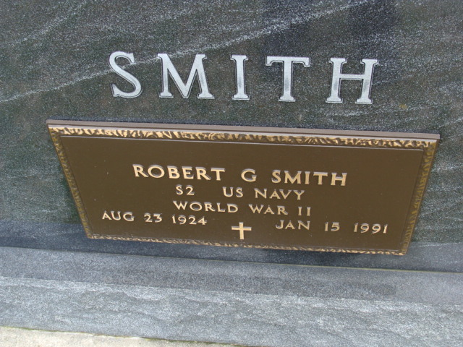
Photo by Alicia Kneuss

Robert G. Smith, 66, of Rt. 3 Decatur, died Jan. 15, 1991, at Lutheran Hospital in Decatur. Born Aug. 23, 1924, in Flora, he was the son of Glen and Ruth Garrison Smith. His marriage on Dec. 27, 1947, at Fort Wayne, was to Roberta Calvert, who survives.
A 1942 graduate of Flora High School, he earned his bachelor’s degree at Purdue University and his law degree at Northwestern University. He became a Decatur attorney in 1950. He was a partner in the firm of Smith-Burry-Herman & Miller.
A longtime member of the Indiana State Bar Association, he served as Adams County attorney for the towns of Monroe and Geneva, the Adams County Board of Health, the Planning Committee and the Board of Zoning Appeals. At one time he was attorney for
Adams Central Community Schools and was on the board of directors of the Bank of Geneva.
A veteran of World War II, he was past commander and a member of Adams County American Legion Post 42 and Decatur Rotary Club. He was also a member of Decatur Masonic Lodge, Scottish Rile Valley of Fort Wayne, Mizpah Temple of the Shrine of Fort Wayne and Decatur First United Methodist Church.
Also surviving is a daughter, Lou Anne Stevens, and two sons, Terry and Steven, all of Decatur; his mother of Flora; a sister, Annabelle Sparks of Rt. 1, Bringhurst; and four grandchildren.
Services and burial were at Decatur Friday.

Carroll County Comet, Caroll County, Indiana
January 23, 1991

**
Indiana, U.S., Death Certificates, 1899-2017
Name Robert G Smith
Gender Male
Race White
Marital Status Married
Age 66
Birth Date 23 Aug 1924
Birth Place Flora, Indiana
Death Date 15 Jan 1991
Death Place Fort Wayne, Allen, Indiana, USA
Death Registration Date 1991
Father Glen J Smith
Mother Ruth Garrison Smith
Spouse Roberta Calvert
Informant Roberta Smith; wife; Decatur, Indiana
Burial January 18, 1991; Decatur Cemetery; Decatur, Indiana

