Richard Earl Smith
February 10, 1884 – December 31, 1926

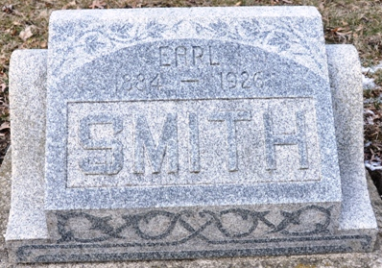
Photo by Deb Curry

Indiana Births, 1880-1920
Name: Smith, ___
Father: Wm R; Mother: Nancy A Rice
County: Adams
Gender: Male
Birth Date: 10 Feb 1884
Reference: Adams County, Indiana Index to Birth Records 1882 - 1920 Inclusive Volume I Letters A - Z Inclusive, Book: H-1, Page:110
**
Indiana, U.S., Death Certificates, 1899-2017
Name Richard Earl Smith
Gender Male
Race White
Age 42
Birth Date 10 Feb 1884
Birth Place Adams County, Indiana
Death Date 31 Dec 1926
Death Place Wayne, Allen, Indiana, USA
Death Registration Date 1926-1927
Father William Smith
Mother Sarah [sic] Rice
Informant R. D. Moyers; Decatur, Indiana
Burial January 2, 1927; Decatur Cemetery

