Richard Albert Smith
August 25, 1907 – November 4, 1955

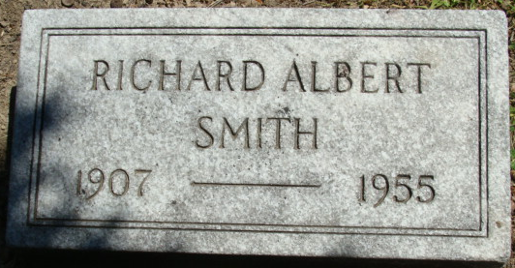
Photo by Alicia Kneuss

Richard A Smith
in the Indiana, U.S., Death Certificates, 1899-2017
Name Richard A Smith
Gender Male
Race White
Marital Status Married
Age 48
Birth Date 25 Aug 1907
Birth Place Decatur, Indiana
Death Date 4 Nov 1955
Death Place Fort Wayne, Allen, Indiana, USA
Death Registration Date 1955
Father David E Smith
Mother Ethal Hale
Informant Margaret Smith; Fort Wayne, Indiana
Burial November 7, 1955; Maplewood Cemetery; Decatur, Indiana

