Reuben Noah Smith
March 12, 1898 – March 26, 1967

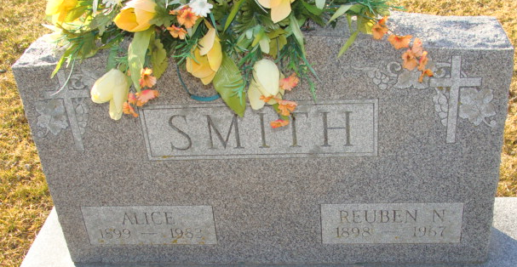
Photo by Alicia Kneuss

Reuben N Smith
in the Indiana, U.S., Death Certificates, 1899-2017
Name Reuben N Smith
Gender Male
Race Caucasian (White)
Marital Status Married
Age 69
Birth Date 12 Mar 1898
Death Date 26 Mar 1967
Death Place Fort Wayne, Allen, Indiana, USA
Death Registration Date 1967
Father Simon Smith
Mother Martha
Informant Mrs. Alice Smith; wife; Decatur, Indiana
Burial March 28, 1967; Decatur Cemetery; Decatur, Indiana

