Ralph E. Smith, Sr.
April 7, 1905 – April 29, 1997

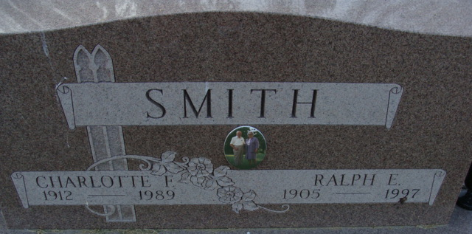
Photo by Alicia Kneuss

Ralph E. Smith, Sr., 92, of Decatur died Tuesday at Chalet Village Health Care Center, Berne. The Pleasant Mills native was a chemist who worked for Kraft Foods in Kendallville, Crawfordsville and Decatur and Sealtest Dairy in Huntington.
He also started Smith Dairy, Decatur, in 1947, retiring in 1966. He also had been custodian at First United Methodist Church, Decatur. His wife, Charlotte, died in 1989.
Surviving are his son, Ralph E. of Decatur; brothers, Allen of Ortonville, Mich. and Roy of Evansville; sisters, Irene Gay of Greenville, Mich., Ruth Johns of Van Wert, Ohio and Veda Smith of Decatur; three grandchildren; and four great-grandchildren.
Services are 1:30 p.m. Sunday at the church, where calling is 12:30 to 1:30 p.m.; calling also is 2 to 4 and 6 to 8 p.m. Saturday at Haggard & Armes Funeral Home, Decatur. Burial will be in Decatur Cemetery.
News-Sentinel, Allen County, Indiana
May 2, 1997

