Ralph Evan Smith, Jr.
April 12, 1931 – October 16, 2012

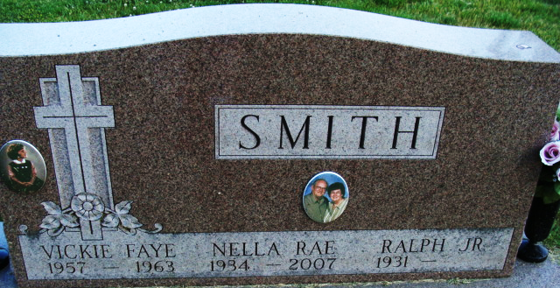
Photo by Alicia Kneuss

Ralph E. Smith Jr., 81 of Decatur, Ind. passed away on Tuesday, October 16 at a hospital in Texas. He was born on April 21, 1931 in Paoli, Ind. to the late Ralph E. Smith Sr and Charlotte F. Smith. He married Nella R (Potter) Smith on June 13, 1953; she died on October 28, 2007.
He is survived by 3 sons, Allen R. Smith of Wenatchee, WA, James B. (Judy) Smith of Fort Wayne, Ind, and Scott E. (Elva) Smith of San Isidro, Tx. He was preceded in death by his daughter Vicky F. Smith. He has 6 grandchildren, Jeffrey, Evan, Tyler, Jonathan, Christopher, and Delia, and 3 great-grandchildren, Kaiden, Maykayla, and Aaliyah.
Ralph was a member of the First United Methodist Church where he served on the Trustee, past chairman of Trustee’s was in the Alpha Omega Sunday School class, was a Sunday School teacher and served on the Kid's First Child Care board.
He was an inspector for 7 years with the Weight & Measures, a charter member of J.C.'s and former member of the Decatur Lions Club. He was also a Korean War Veteran and member of the Adams County Board of Elections. He retired from E & L Transport.
Visitation will be from 2:00-4:00 p.m. and from 6:00-8:00 p.m. on Monday, October 22, 2012 at Haggard-Sefton & Hirschy Funeral Home. Funeral Services will be held at 10:00 a.m., Tuesday October 23, 2012 at the First United Methodist Church with calling one hour prior to service. Rev Martha Lyon will be officiating. Burial will graveside rites by American Legion Post #43 Color Guard.
Memorials may be made to the First United Methodist Church.

Haggard & Sefton Funeral Home, Adams County, Indiana
October 17, 2012
**
Indiana, U.S., Birth Certificates, 1907-1944
Name Ralph Evan Smith Jr
Gender Male
Birth Date 21 Apr 1931
Birth Place French Lick, Orange, Indiana, USA
Father Ralph Evan Smith; age 26
Mother Charlotte Fay Clark; age 18
Certificate Number 17234
Roll number 40474_356531

