R. Byron “Smitty” Smith
March 4, 1910 – September 30, 1988

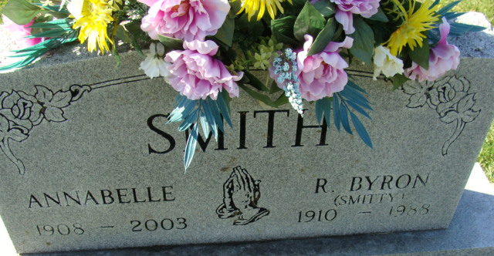
Photo by Alicia Kneuss

R Byron Smith
in the Indiana, U.S., Death Certificates, 1899-2017
Name R Byron Smith
Gender Male
Race White
Marital Status Married
Age 78
Birth Date 4 Mar 1910
Birth Place Macy, Indiana
Death Date 30 Sep 1988
Death Place Decatur, Adams, Indiana, USA
Death Registration Date 1988
Father Charles Smith
Mother Minnie Pulver
Spouse Annabelle Yike
Informant Annabelle Smith; wife; Decatur, Indiana
Burial October 3, 1988; Decatur Cemetery; Decatur, Indiana

