Perry E. Smith
September 16, 1891 – January 6, 1979

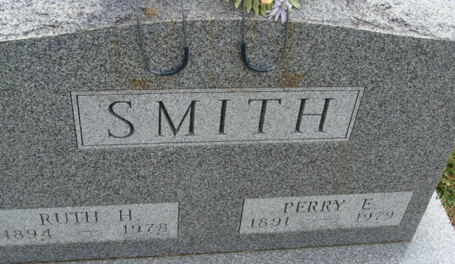
Photo by Alicia Kneuss

Private family services for Perry E. Smith, 87, former of 4025 Lower Huntington Road, Fort Wayne, will be held at 10:30 a.m. Tuesday in Elzey-Dickey-Haggard Home for Funerals in Waynedale. He died at 9:40 a.m. Saturday in the Lutheran Home.
A native of Adams County, he was the son of Harvey and Sarah Ann Rowe-Smith. His wife, Ruth, died on March 22, 1978.
He was a retired building contractor and was a charter member of the Waynedale Lions Club, were he was active for 40 years.
He is survived by two daughters, Mary Lou Adkisson, Fort Wayne, and Margaret A. Piatt, Jacksonville, Fla., and a sister, Ocie Durr, Decatur.
Burial will be in Decatur Cemetery. Friends may call from 2 to 5 and 7 to 9 p.m. today at the funeral home.

Decatur Daily Democrat, Adams County, Indiana
January 8, 1979

**
Indiana, U.S., Death Certificates, 1899-2017
Name Perry E. Smith
Gender Male
Race White
Marital Status Widowed
Age 87
Birth Date 16 Sep 1891
Birth Place Indiana
Death Date 6 Jan 1979
Death Place Fort Wayne, Allen, Indiana, USA
Death Registration Date 1979
Father Harvey Smith
Mother Sarah Ann Roe
Informant Mary Lou Adkisson; Fort Wayne, Indiana
Burial January 9, 1979; Decatur Cemetery; Decatur, Indiana

