Pansy Smith
March 9, 1917 – August 24, 1933

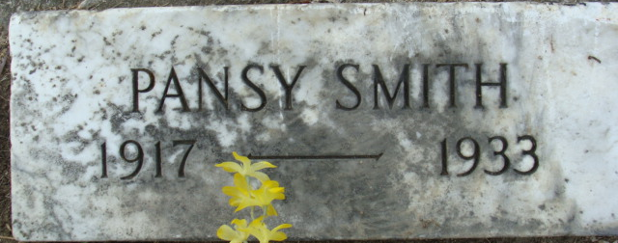
Photo by Alicia Kneuss

Pansy Smith
in the Indiana, U.S., Death Certificates, 1899-2017
Name Pansy Smith
Gender Female
Race White
Marital Status Single
Age 16
Birth Date 9 Mar 1917
Birth Place Plymouth, Indiana
Death Date 24 Aug 1933
Death Place Decatur, Adams, Indiana, USA
Death Registration Date 1933
Father F.W Smith
Mother Katherine Warnick
Informant F. W. Smith; Decatur, Indiana
Burial August 26, 1933; Decatur Cemetery
**
Pansy Smith from tree S and A Morrison Family Tree
Birth 9 Mar 1917 Plymouth, Marshall, Indiana, USA
Residence 1930 Decatur, Adams, Indiana, USA
Death 24 Aug 1933 Decatur, Adams, Indiana, USA
Father Franklin W. Smith (1867-1950)
Mother Katherine F. Warnick (1875-1950)

