Ortha Smith
1896 – October 3, 1897

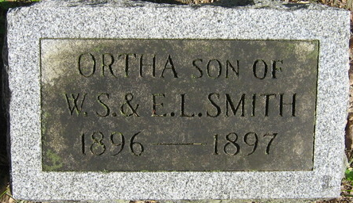
Photo by Alicia Kneuss

Ortha Smith from tree Wickizer,Holcomb,Wallace,Small
Birth 1896 Monroe City, Adams, Indiana, USA
Death 3 Oct 1897 Monroe City, Adams, Indiana, USA
Father Wilford Samuel Smith (1866-1949)
Mother Electa Lucetta Macy (1866-1938)

