Nella R. (Potter) Smith
November 5, 1934 – October 28, 2007

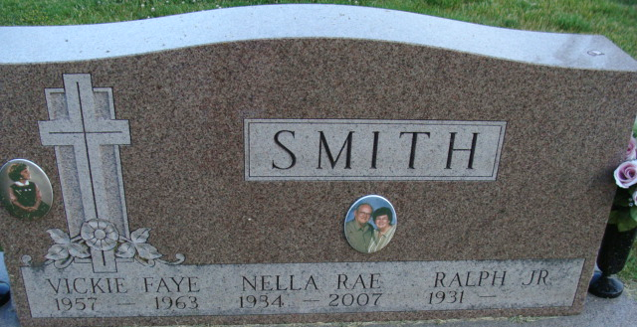
Photo by Alicia Kneuss

Nella R. Smith, 72 of rural Decatur passed away Sunday, October 28, 2007 at Adams Memorial Hospital. Nella was born in Dayton, Tennessee on November 5, 1934 to the late Dillon & Mildred R. (Hall) Potter. She married Ralph E. Smith Jr. on June 13, 1953.
Survivors include her husband Ralph E. Smith Jr. of Decatur, IN; 3 sons Allen R. Smith of Wenatchee, Washington, James B. (Judy) Smith of Ft. Wayne, IN, Scott E. (Elva) Smith of La Gloria, Texas; 3 brothers Carl Y. (Alta) Potter of Spring City, Tennessee, Leslie H. (Donna) Gentry of Dayton, Tennessee, Ellis Pat (Molly) Gentry of Dayton, Tennessee; 2 sisters Alice F. Ervin of Dayton, Tennessee, Mrs. Chris (Lois) Hoose of Dayton, Tennessee; Six grandchildren and 1 great grandchild.
Preceded her in death are her parents, a daughter Vickie Faye on 6/11/1963 and a brother James Gentry.
Nella was a member of the First United Methodist Church, its Alpha Omega Sunday school class, the Hope Chest Board and United Methodist Women. She worked for Central Soya for 12 years and North Adams Community Schools as an Aide for 15 years at Monmouth Elementary.
Calling hours are from 2-4 & 6-8 pm Wednesday, October 31, 2007 at Haggard & Sefton Funeral Home and 1 hour prior to services at the church. Funeral service will be held at 11:00 am Thursday, November 1, 2007 at the First United Methodist Church. Rev. Ken Mahan and Pastor Loren Felabom will be officiating and burial is in Decatur Cemetery.
Memorials are to First United Methodist Church or Cancer Services of Ft. Wayne.

Haggard & Sefton Funeral Home, Adams County, Indiana
October 29, 2007

**
Indiana, U.S., Death Certificates, 1899-2017
Name Nella R Smith
[Nella R Potter]
Gender Female
Race Caucasian (White)
Marital Status Married
Age 72
Birth Date 5 Nov 1934
Birth Place Dayton, Tennessee
Death Date 28 Oct 2007
Death Place Decatur, Adams, Indiana, USA
Death Registration Date 2007
Father Dillon Potter
Mother Mildred R Hall
Spouse Ralph E Smith, Jr.
Informant Ralph E. Smith, Jr.; spouse; Decatur, Indiana
Burial November 1, 2007; Decatur Cemetery; Decatur, Indiana

