Nancy Ann (Smith) Smith
January 11, 1833 – August 25, 1895

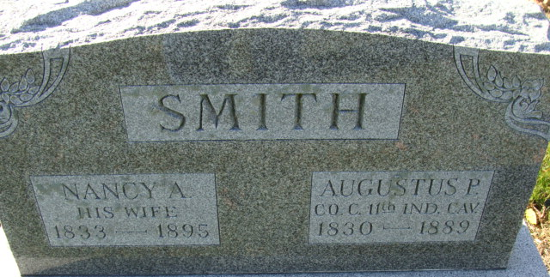
Photo by Alicia Kneuss

Mrs. Nancy Smith, widow of the late Augustine P. Smith, died Monday about 4 o’clock p.m. of heart failure. She had been sick but a few hours. The funeral was held at the M.E. Church Tuesday at 3 p.m., Elder Vaughan officiating. The deceased was one of the old settlers of this county.

Decatur Democrat, Adams County, Indiana
Friday, August 30, 1895

**
Mrs. Nancy Smith was born in Fayette County, Ohio, in 1833 and came to Adams County with her parents in 1836. She was married to Augustine P. Smith in 1853.
Eight children being born to them, two having died in infancy, the other six surviving to mourn her loss. She was a widow 6 years, her husband having died June 28, 1889.
She was a member of the Methodist Church, having professed Christianity in early life, and remained faithful until her death which occurred at her home Sunday afternoon, August 25, 1895, aged 62 years 7 months and 14 days.
Her funeral was held at the M.E. Church, Rev. Vaughan officiating. Interment in Maplewood Cemetery.

Decatur Democrat, Adams County, Indiana
Friday, September 6, 1895

**
Nancy Ann Smith from Case Family Tree
Spouse Augustus P Smith
Father Zachariah Smith
Mother Susanna McClelland
Children Zacharia Irving
Birth 11 Jan 1833 Wayne, Fayette, Ohio, USA
Death 25 Aug 1895 Adams, Indiana, USA
Residence 1870 Adams, Indiana, USA

