Mildred L. (Clark) Smith
November 12, 1922 – March 22, 2004

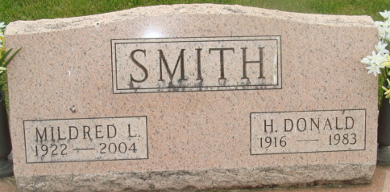
Photo by Alicia Kneuss

Mrs. Mildred L. Smith passed away Monday at the Adams County Memorial Hospital at 12:17am. She was born in Mexico, Indiana on November 12, 1922 to Harry and Helen (Cook) Clark. She later married Harry (Don) Smith. (He passed away on March 17, 1983)
Mildred was a homemaker and also a bookkeeper for Smith's Sunoco Service Station, Decatur, IN. She was a member of the Union Chapel United Methodist Church, Decatur the Work and Win Sunday School Class, Faith Circle of United Methodist Women, Chairperson of the Pastor Parish Committe, she served on the Auditing Committee, chairperson of the Bereavement Committee, Live and Learn Home Economics Club, a member of the Adams County Extension Homemakers and the Washington Township Election Board.
Unknown source

**
Indiana, U.S., Death Certificates, 1899-2017
Name Mildred L Smith
[Mildred L Clark]
Gender Female
Race White
Marital Status Widowed
Age 81
Birth Date 12 Nov 1922
Birth Place Mexico, Indiana
Death Date 22 Mar 2004
Death Place Decatur, Adams, Indiana, USA
Death Registration Date 2004
Father Harry E Clark
Mother Helen R Cook
Informant Mrs. Phyllis Egly; daughter; Decatur, Indiana
Burial March 25, 2004; Decatur Cemetery; Decatur, Indiana

